**Project Design Phase-II Technology Architecture**

|  |  |
| --- | --- |
| Date | 13.10.2022 |
| Team ID | PNT2022TMID02102 |
| Project Name | Project - Smart farmer - IOT enabled smart farming application |
| Maximum Marks | 4 Marks |

**Technology Architecture:**

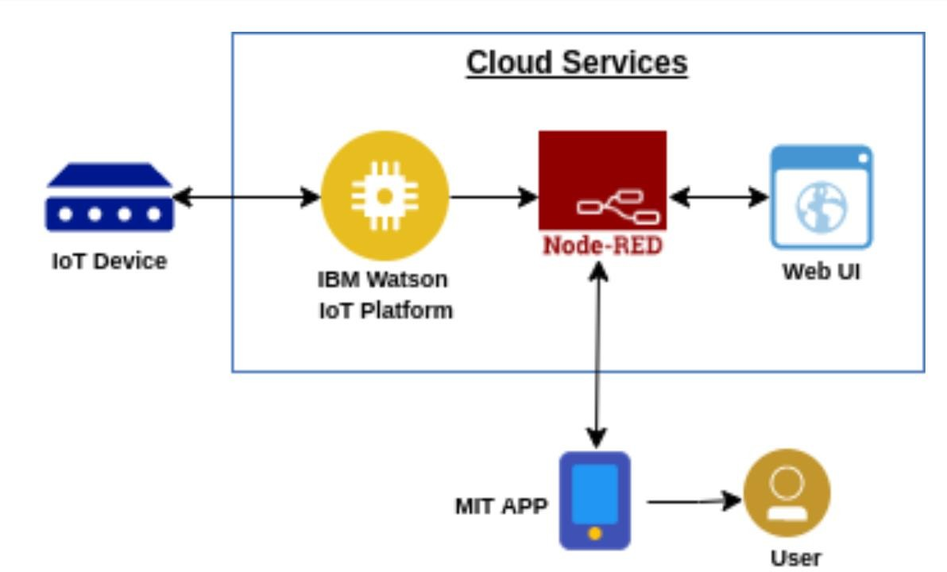

**IOT Device -** IoT devices include computer devices, software, wireless sensors, and actuators

**IBM Watson IoT Platform -** IoT devices include computer devices, software, wireless sensors, and actuators.

**Node-RED -** Node-RED is a programming tool for wiring together hardware devices, APIs and online services in new and interesting ways

**Web UI -** The Web UI is a streamlined Web-based application with a user-friendly interface that allows you to easily manage the NetScreen appliance.

**MIT App -** App Inventor is a cloud-based tool, which means you can build apps light in your web browser.

**User –** User is the one who uses the software.